**Course Number: 420-DW4-AS**

**Course Title: Web Server Applications Development II**

**Session: Autumn 2023**

**Group: 7262**

FINAL PROJECT REPORT

TITLE: Property Rental Management Web Site

DUE DATE: **November 30, 2023**

SUBMITTED

To

TEACHER: QUANG HOANG CAO

JONAH ZHOU 2130068

1. PROJECT DESCRIPTION

**Property Rental Management Web Site** serves as a comprehensive platform designed to streamline property rental processes for both property owners and potential tenants. The system is structured to accommodate the distinct roles of Property Owners/Administrators, Property Managers, and Potential Tenants, offering tailored functionalities to meet their specific needs.

1. PROJECT DEVELOPMENT

PHASE I ANALYSIS

1. Introduction:

Purpose: The purpose of this document is to outline the functional requirements of the Property Rental Management Web Site, detailing the features and capabilities that the system must possess to meet the needs of Property Owners, Property Managers, and Potential Tenants.

Scope: The system will cover account management, property and apartment operations, appointment scheduling, communication, and reporting functionalities.

2. User Roles:

Property Owner/Administrator:

* Account Management
* Tenant Management
* Web Site Control

Property Manager:

* Building Operations
* Apartment Operations
* Status Tracking
* Appointment Scheduling
* Communication and Reporting

Potential Tenants:

* Account Creation
* Apartment Exploration
* Appointment Booking
* Communication

3. Functional Requirements:

3.1 Property Owner/Administrator:

3.1.1 Account Management:

* Create a new Property Manager account.
* Update details of an existing Property Manager account.
* Delete a Property Manager account.
* Search and list Property Manager accounts.

3.1.2 Tenant Management:

* Update details of an existing Potential Tenant account.
* Delete a Potential Tenant account.
* Search and list Potential Tenant accounts.

3.1.3 Web Site Control:

* Full control over the web site.
* Monitor and manage overall system functionality.

3.2 Property Manager:

3.2.1 Building Operations:

* Create a new building entry.
* Update details of an existing building.
* Delete a building entry.
* Search and list buildings.

3.2.2 Apartment Operations:

* Create a new apartment entry.
* Update details of an existing apartment.
* Delete an apartment entry.
* Search and list apartments.

3.2.3 Status Tracking:

* Mark apartments as available, occupied, or under maintenance.
* Track and manage apartment status changes.

3.2.4 Appointment Scheduling:

* Schedule appointments with Potential Tenants.
* View and manage appointment schedules.

3.2.5 Communication:

* Respond to messages from Potential Tenants.
* Facilitate effective communication within the system.

3.2.6 Reporting:

* Generate and view reports on relevant events.
* Provide Property Owners/Administrators with insights.

3.3 Potential Tenants:

3.3.1 Account Creation:

* Create a new online account.
* Provide necessary information for account setup.

3.3.2 Apartment Exploration:

* View apartments based on specified criteria.
* Explore details of available apartments.

3.3.3 Appointment Booking:

* Schedule appointments with Property Managers.
* Confirm and manage appointment schedules.

3.3.4 Communication:

* Send messages to Property Managers.
* Receive and manage communication within the system.

4. Non-functional Requirements:

4.1 Performance:

* The system should handle concurrent user activities efficiently.

4.2 Security:

* User authentication and authorization mechanisms should be robust.

4.3 Usability:

* The user interface should be intuitive and user-friendly.
* Help documentation and tooltips should be provided where necessary.

5. Constraints:

* The system must comply with relevant data protection and privacy regulations.
* Compatibility with modern web browsers (Chrome, Firefox, Safari, Edge) is required.

PHASE II DESIGN

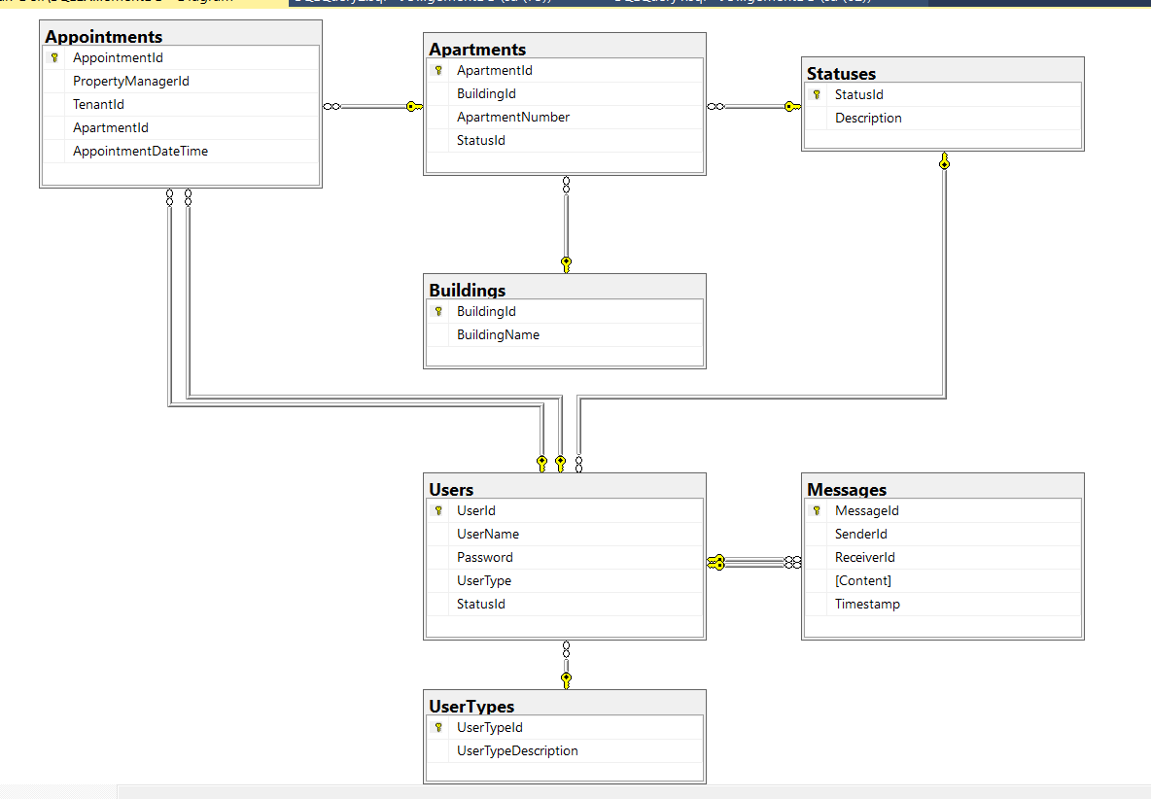

PHASE III IMPLEMENTATION

[Property Rental Management Web Site (github.com)](https://github.com/jonah-zhou/Web-Server-Applications-Develop/tree/master/Final%20Project)

PHASE IV TESTING THE PROGRAM

| **User Role** | **Functional Requirement** | **Test Result/Problem(s)** |
| --- | --- | --- |
| Property Owner/Administrator | Create Property Manager Account | Test Passed |
| Property Owner/Administrator | Update Property Manager Account | Test Passed |
| Property Owner/Administrator | Delete Property Manager Account | Test Passed |
| Property Owner/Administrator | Search/List Property Manager Accounts | Test Passed |
| Property Owner/Administrator | Update/Delete/Search/List Potential Tenant Account | Test Passed |
| Property Owner/Administrator | Full Control of the Website | Test Passed |
| Property Manager | Perform CRUD operations related to buildings | Test Passed |
| Property Manager | Perform CRUD operations related to apartments | Test Passed |
| Property Manager | Keep track of apartment status | Test Passed |
| Property Manager | Schedule potential tenant appointments | Test Passed |
| Property Manager | Respond to potential tenant messages | Test Passed |
| Property Manager | Send message to the property owner when necessary | Test Passed |
| Potential Tenant | Create an online account through the Property Rental Website | Test Passed |
| Potential Tenant | View apartments suitable for their needs | Test Passed |
| Potential Tenant | Make an appointment with the property manager | Test Passed |
| Potential Tenant | Send necessary messages to the property manager | Test Passed |
| Performance | System handles concurrent user activities efficiently | Test Passed |
| Security | Robust user authentication and authorization mechanisms | Test Passed |
| Usability | Intuitive and user-friendly interface | Test Passed |

1. CONCLUSION

This course has provided me with valuable insights into critical thinking, autonomy initiative, time management and analytic and synthetic. I have developed a deeper understanding of key concepts such as analyzing, designing, implementing and testing an application using Visual Studio 2022, ASP.NET Core MVC/ASP.NET MVC, C# and SQL Server 2019, and I have honed my skills in analyze the application development project, prepare the database, program the Web interface, program the server-side and client-side application logic. The hands-on projects and assignments have not only challenged me but also equipped me with practical knowledge that I can apply in real-world scenarios.

1. BIBLIOGRAPHY
2. [Overview of ASP.NET Core MVC | Microsoft Learn](https://learn.microsoft.com/en-us/aspnet/core/mvc/overview?view=aspnetcore-8.0)
3. [Tutorial: Create a C# ASP.NET Core web app in Visual Studio - Visual Studio (Windows) | Microsoft Learn](https://learn.microsoft.com/en-us/visualstudio/get-started/csharp/tutorial-aspnet-core?view=vs-2022)
4. [ASP.NET Core MVC Framework - Dot Net Tutorials](https://dotnettutorials.net/lesson/introduction-asp-net-core-mvc/)
5. [ASP.Net Core MVC Tutorial - Code Maze (code-maze.com)](https://code-maze.com/asp-net-core-mvc-series/)
6. ChatGPT